DAY-3 outputs

PROGRAM-1



PROGRAM-2

PROGRAM-3

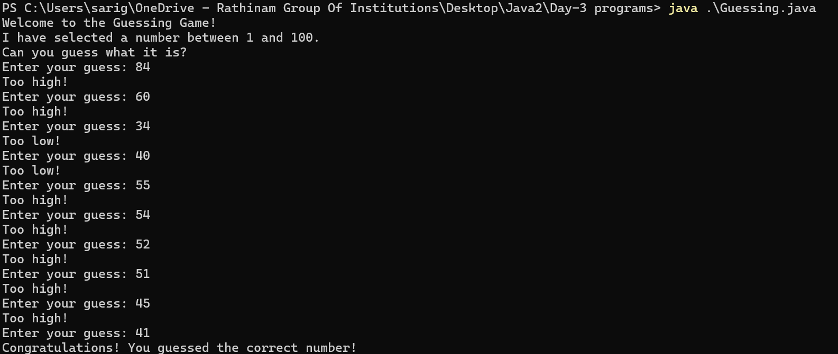

PROGRAM-4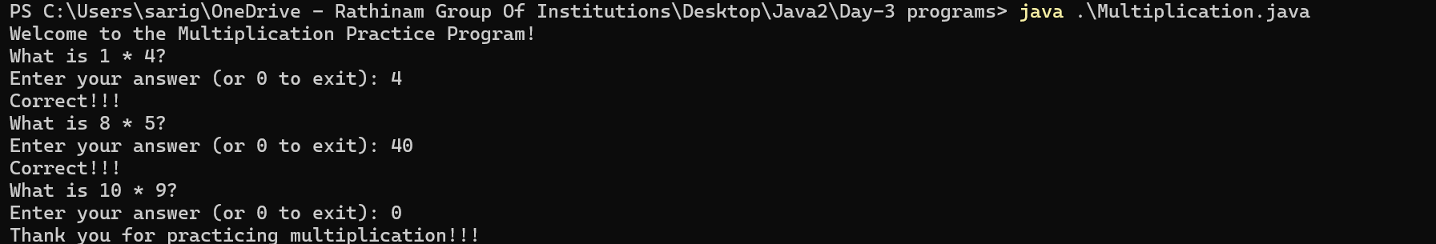

PROGRAM-5

PROGRAM-6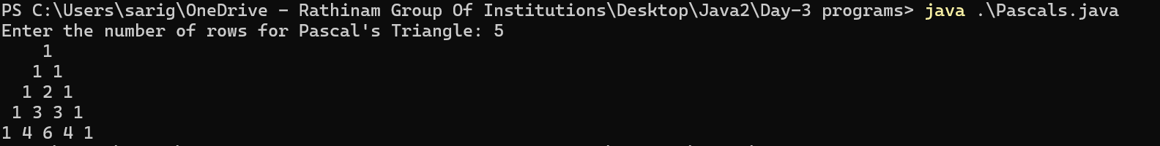

PROGRAM-7



PROGRAM-8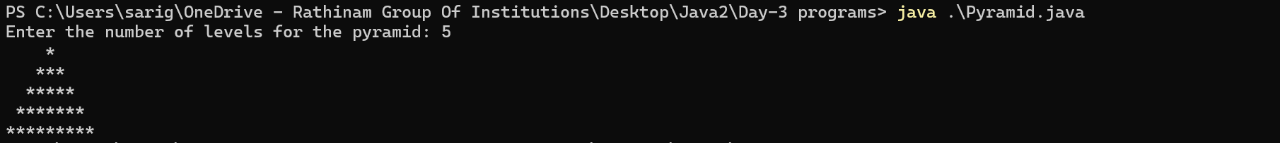

PROGRAM-9

PROGRAM-10